The Salesforce Industries solution offers:

* **Reusablility:** A component-oriented system with reusable items which live independently of products
* **Pricing types:** Categories of pricing such as penalties, charges, and adjustments to existing charges
* **Frequency:** Settings that determine the frequency of the charge
* **Easier updating**: Ability to transition from older pricing to newer pricing for less expense and disruption

With Salesforce Industries' pricing model, you can:

* Use different methods to price bundles of products
* Assign more than one base price to a product
* Separate pricing for business needs, such as employee discounts or customer service level agreements

**Analyze Product Prices and Their Settings**

When you assign a price to a product, you are creating a price list entry. In this process, you are answering questions like these:

* Is this a price or a cost?
* How often should the price be applied?
* How much is the price?
* Is this the base price or an adjustment?
* Is this a standard price or a penalty fee?

A product price is a set of pricing components assigned to a product. Salesforce Industries' pricing approach:

* Provides components to create all the aspects of pricing
* Separates the price and its nuances from the product

# Assigning Base Prices

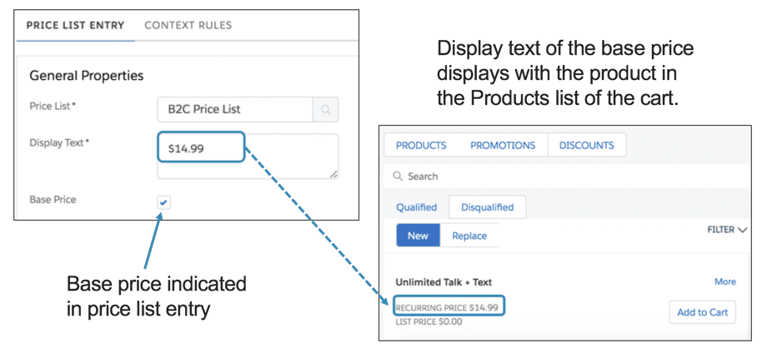

**Base Price and Display Text**

To mark a price as the base price, select the **Base Price**option when you create the price list entry. The display text of the base price appears along with the product in the **PRODUCTS** list of the Cart.

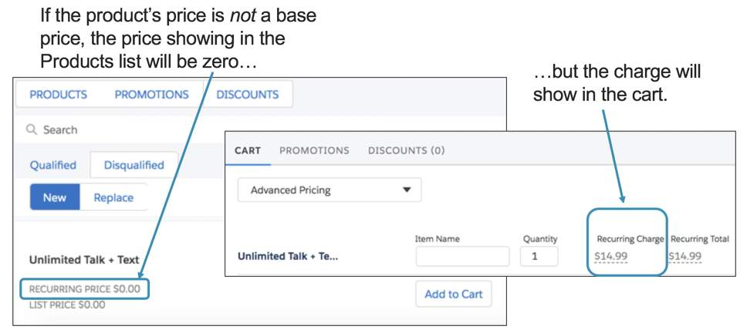

**Prices Not Marked as Base Price**

If a product has no price list entries marked as a base price, the prices in the **PRODUCTS** list will display as zero. However, the charge will show in the Cart.

# Pricing Components

**Price Lists**

By using price lists:

* You can assign more than one base price to a product by creating price list entries stored in different price lists.
* You can create price lists based on the needs of your business. For example, you may wish to separate customer pricing from wholesale pricing, or from employee pricing.

**Price List, Price Book**

How does a price list relate to a Salesforce price book? Every price list is associated with a price book, because the price book is required by Salesforce. Salesforce Industries uses the Salesforce price book as a pass-through.

When you install your Salesforce Industries managed package for the first time, you will create a single price book in Salesforce. From then on, you can associate every price list you create with the same price book.

**Parent/Child Price Lists**

A price list can be a parent that has child price lists. The parent price list will contain pricing elements that you want to use in all its child price lists.

**Context Rules and Child Price Lists**

You can use a context rule to apply a price list entry located in a child price list based on whether the account meets a specific condition.

For example, suppose you want to set different prices, depending on the geographic location of the account. You can write a context rule to retrieve price list entries from the California child price for California accounts, and from the Nevada child price list for Nevada accounts.

**Pricing Variables and Pricing Elements**

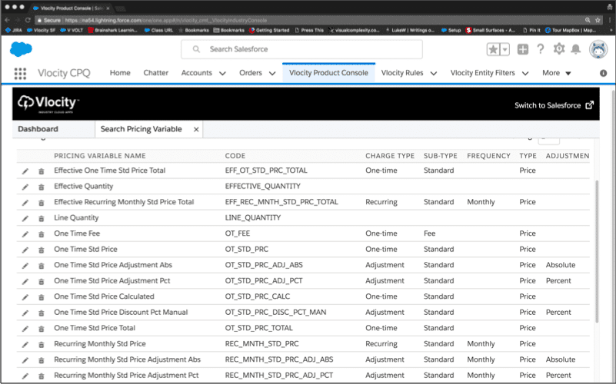

**Pricing Variables**

Pricing variables enable you to set a type of price that you can associate with a charge. Type determines:

* Whether it is a regular charge or a penalty fee
* How frequent – whether the charge is for one time or ongoing
* Whether it is a price charged to the customer or a cost the company must bear
* Whether payment of the charge is accomplished with currency or loyalty points

**Pricing Elements**

After you have chosen the type of price, you choose from a list the amounts in the price list that are associated with that pricing type. A pricing element combines the pricing variable with the amount and currency.

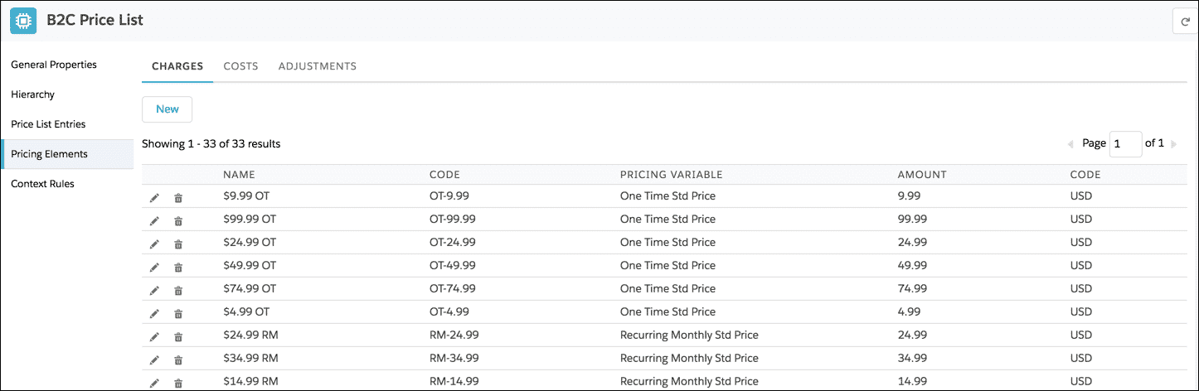

# Multiple Base Prices, One Price List: Changing Price Over Time

You can create multiple price list entries for the same product using the same price list. To prevent these price list entries from interfering with each other, each price list entry can have an effectivity date range. When you use this technique, the product's price can change over time as each price list entry becomes effective.

**Using Effectivity Date Ranges**

You can use the **Effective From** and **Effective Until** fields to assign a set of base prices that decrease over time. For example, this table shows a price reducing by 10% each month.

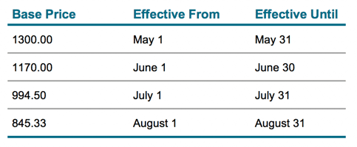

**Gaps In Effectivity Date Ranges**

If there are gaps between the effectivity date ranges for the base price, the product will not appear in the product list of the Cart. For example, a gap between May 16 and May 23.

# The Basics of Bundles

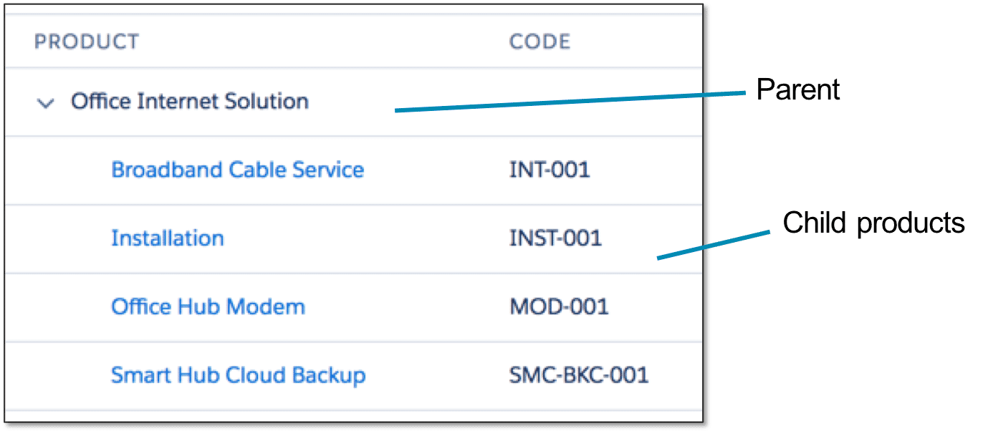

A bundle is a logical grouping of products into one "package". The top level of the bundle is considered the parent product. All products under this level are considered child products.

**The Basics of Bundles**

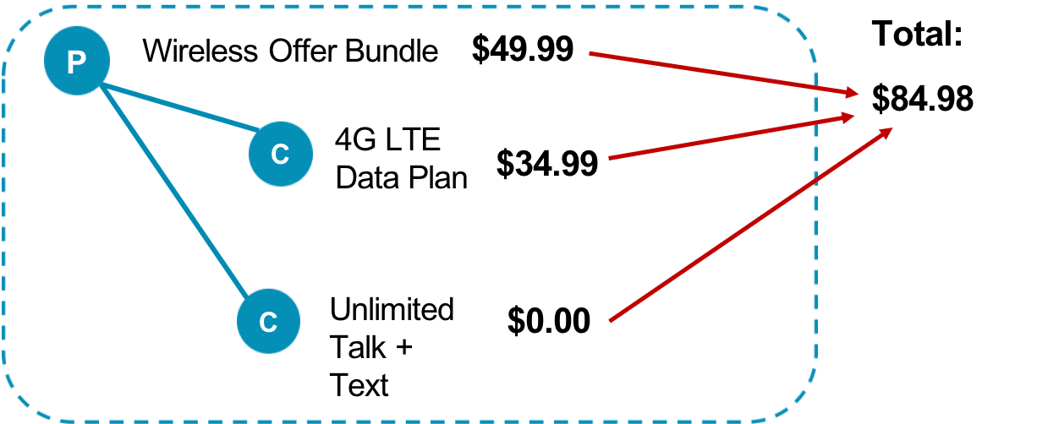

**How are the prices of bundles totalled?**

**Rolled Up Pricing**

The prices of child products and the parent product always roll up into the total for the bundle

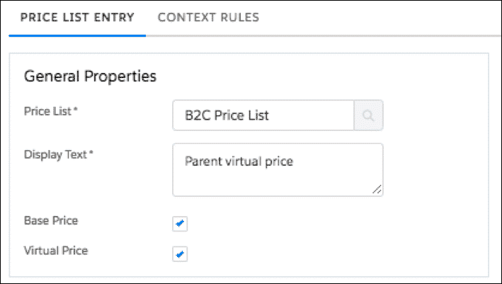

When the parent product of a bundle is priced at $0 and Virtual Price is checked on the price list entry, the price list entries are filtered out of the tightest match evaluation and are not tracked as a price tagged to the bundle in the pricing log or generated as a base price in the price adjustment records.

# Bundles with Optional Child Products

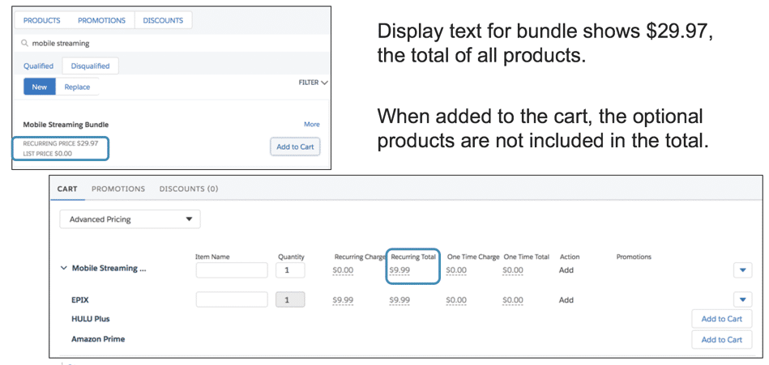

When bundles contain optional products, the display text might show the total price if all the products are purchased. However, unless all products are added to the Cart, the price in the Products list of the Cart won’t match what you see in the Cart.

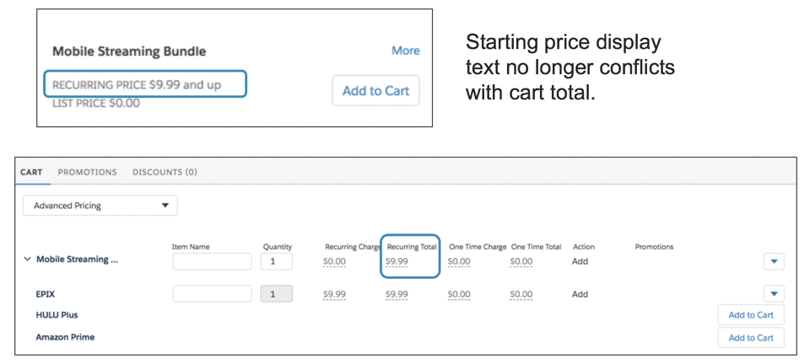

You can change the display text to indicate a range or a starting price for these types of bundles.

# Changing Prices of Child Products

You can change the price of any product or child product in a bundle without altering its base price. Your options are to:

* **Adjust** the price: uses the base price to calculate a percentage discount or an amount discount; or
* **Override** the price: overrides the base price.

**Creating Multiple Price List Entries for One Product**

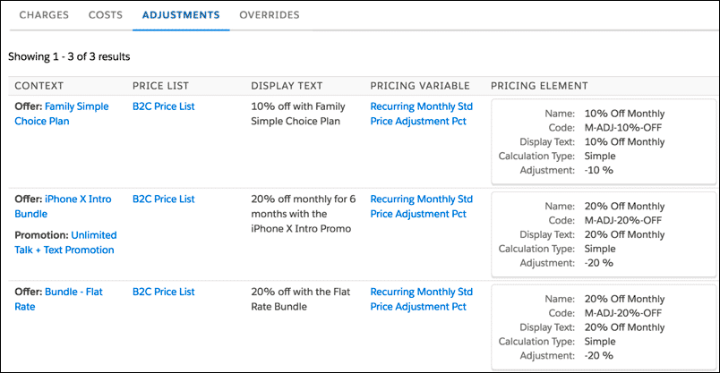

When you create an adjustment or an override to the base price of a product, you are creating a price list entry that is stored in the same price list as the base price. This example shows three different adjustments to the base price for one product. Each adjustment is offered with either different product bundles or a promotion.

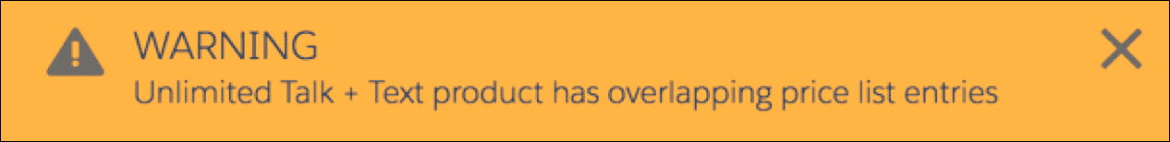

The system reminds you to be aware when you create multiple price list entries in the same price list for the product

**Adjusting Prices of Child Products**

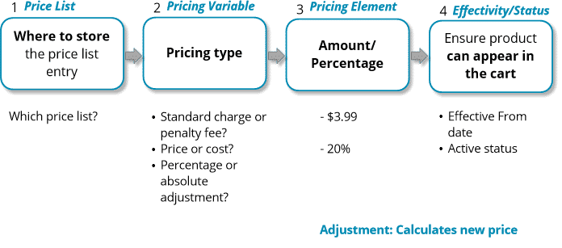

**Overriding Prices of Child Products**

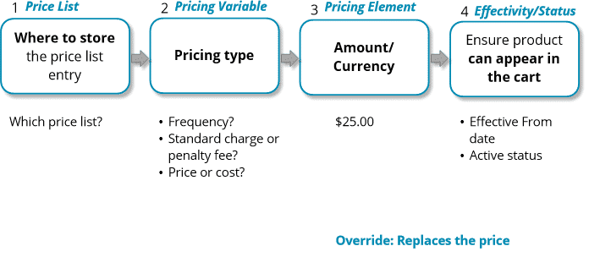

**Where Adjustments and Overrides are Created**

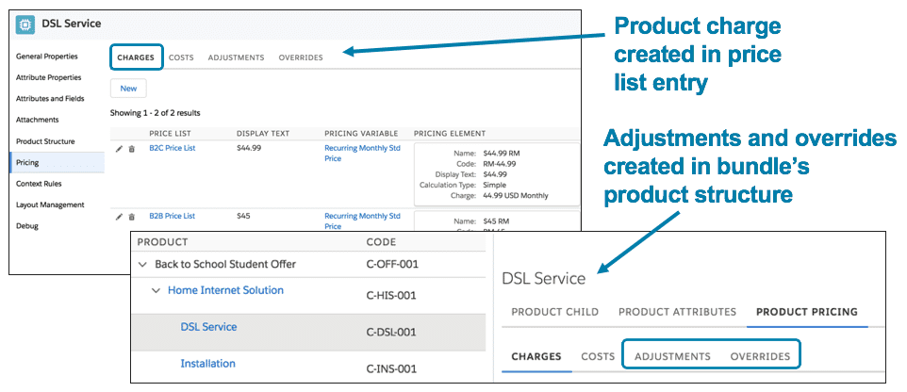

You create charges in the price list entry of the product.

You create adjustments and overrides within the bundle’s product structure.

# Manually Change Prices in the Cart

You can manually change a price in the Cart by:

* Adjusting it with a percentage or amount
* Overriding the price

When you discount a price that is a recurring charge, you can also assign:

* A time plan to limit the time frame of the discount
* A time policy to determine how the discount begins and ends

You can also delete any manual changes you have made to prices in the Cart.

Context rules can be used to control the conditions under which you can make manual pricing adjustments. You can also use context rules to essentially "turn off" this capability and ensure that no manual adjustments are made.

# Pricing Elements

You use pricing components to assign prices to products and to adjust base prices by a percentage or amount. Pricing components are reusable.

**Pricing Elements**

The basic types of pricing elements are:

* **Charges** to assign a base price
* **Adjustments** to adjust a base price
* **Overrides** to override a base price

If you don’t see the price you need in the list of prices with their currency and types, then you must create a new pricing element.

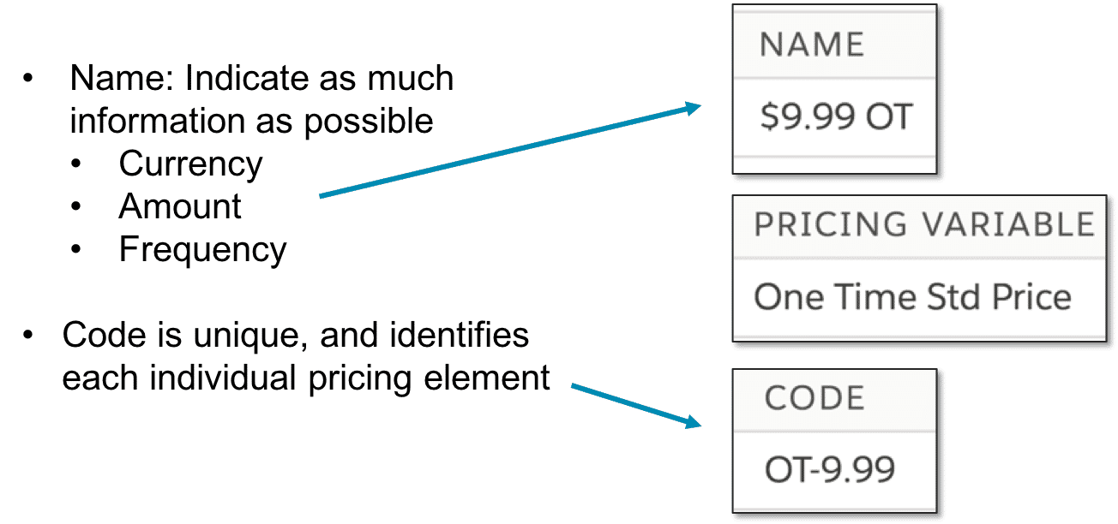

**Best Practices**

The name of the pricing element should indicate as much information about the price as possible, such as the currency, amount, and whether it is a one-time or recurring charge. Additionally, if the charge is recurring, make sure to specify when it recurs.

For example, a recurring monthly charge of $9.99 could be named “$9.99 RM” or “$9.99 Monthly”. The code is a unique code which identifies the individual pricing element.

**Pricing Element for Adjustments**

The component for pricing adjustments is the pricing element adjustment.

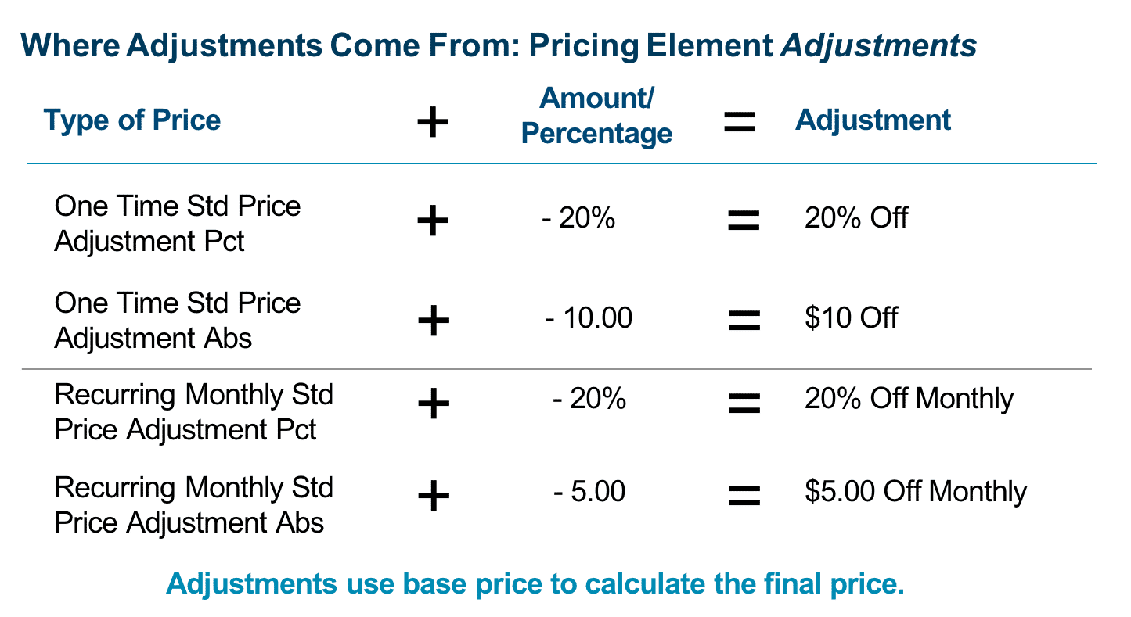

**Pricing Element for Overrides**

The component for pricing overrides comes from pricing element charges, which is the same used for charges assigned to a product.

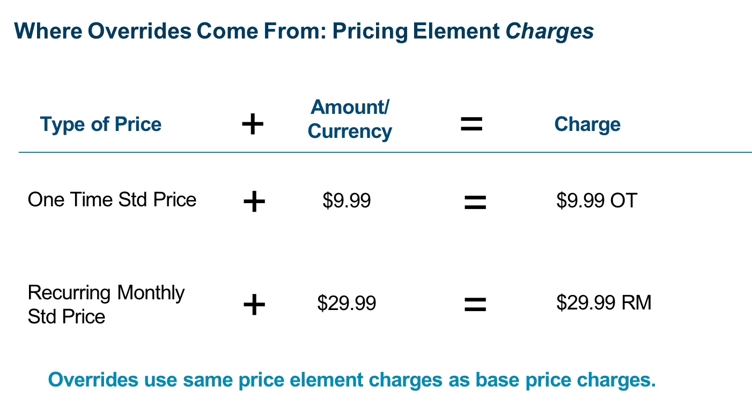

# Time Plans and Time Policies

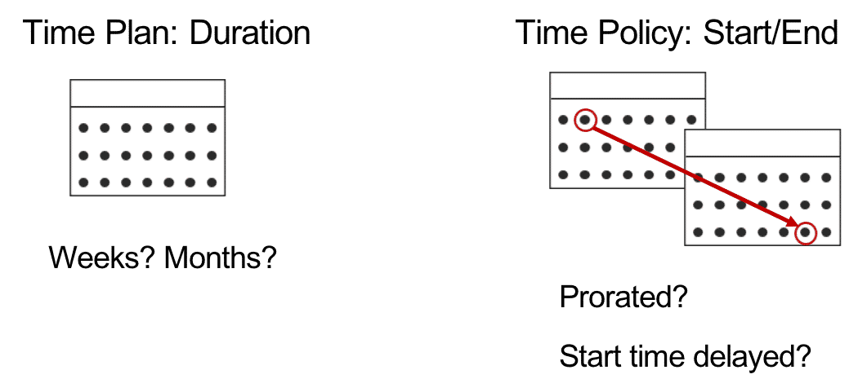

Products such as data plans, internet services, and other ongoing subscription products need a recurring price. You may also need to associate a time plan and a time policy to the price.

**Time Plan Settings**

The time plan is the length of time for pricing to apply to a product. For example, a 2-year subscription to cellular service has a 24-month time plan.

Settings for a time plan include:

* Total duration of the time
* The units of measure for the duration: Day, Week, Month, Year

**Time Policy Settings**

A time policy indicates when the price starts and stops being applied. When you create a time policy, you have these setting options:

**Start Policy**:

* Purchase Date: Typically, the date on which the customer submits payment and signs the agreement
* Cycle Start Date: Date on which the customer’s next billing cycle begins
* First Day of Month: First day of month
* Activation Start: Date on which the customer activates the service or device

**End Policy**:

* End of Plan Duration: The last day of the plan’s duration
* Cycle End Date: The last day of the billing cycle
* Set by Order Management
* Last Day of Month: The last day of the month

**Type**:

* Start Proratable (on/off)
* End Proratable (on/off)

**Start Time Delayed:**

* Start Time Delayed (on/off)
* Delay Offset: Amount, supporting positive and negative numbers
* Delay Offset Unit of Measure: Day, Week, Month, or Year